

Lab # 07

Web Engineering Fall 2020



Instructor | Mr. Safder Ali
Student Name | Hamad Ali Shah
CMSID | 454591
Department | Bs-Cs23
Semester | 5th semester

Lesson Set 7
Introduction to JavaScript

Purpose | 1. | To get a basic awareness of JavaScript
 | 2. | To understand JavaScript and why we are using it.
 | 3. | To learn the basics of JavaScript and create simple forms.
Procedure | 1.  2. | Students should read the Pre-lab Reading assignment before coming to the lab.  Students should complete the Pre-lab Writing assignment before coming to
 | 3. | the lab.  In the lab, students should complete Labs 7.1 through 7.2 in sequence. Your
 | 4. | instructor will give further instructions as to grading and completion of the lab.  Students should complete the set of lab tasks before the next lab and get
 |  | them checked by their lab instructor.

Contents | Pre-requisites | Completion Time | Page Number
Pre-lab Reading Assignment | - | 20 min | 3
Pre-lab Writing Assignment | Pre-lab Reading | 10 min | 4
Lab 7
Lab 7.1  JavaScript | Basics of Programming | 30 min | 5
Lab 7.2  Lab Tasks | Awareness with JavaScript | - | 9

PRE-LAB READING ASSIGNMENT
What Is JavaScript ● JavaScript was designed to add interactivity to HTML pages
- JavaScript is a scripting language
- A scripting language is a lightweight programming language
- JavaScript is usually embedded directly into HTML pages
- JavaScript is an interpreted language (means that scripts execute without preliminary compilation)
- Everyone can use JavaScript without purchasing a license

Start End Tag:
<script type="text/javascript">
</script>

JavaScript is Case Sensitive
Unlike HTML, JavaScript is case sensitive - therefore watch your capitalization closely when you write JavaScript
statements, create or call variables, objects, and functions.

JavaScript Statements
A JavaScript statement is a command to a browser. The purpose of the command is to tell the browser what to do. This JavaScript statement tells the browser to write "Hello " to the web page:
document.write("Hello ");

It is normal to add a semicolon at the end of each executable statement. Most people think this is a good programming practice, and most often you will see this in JavaScript examples on the web.

The semicolon is optional (according to the JavaScript standard), and the browser is supposed to interpret the end
of the line as the end of the statement. Because of this, you will often see examples without the semicolon at the
end.

JavaScript Code
JavaScript code (or just JavaScript) is a sequence of JavaScript statements.
Each statement is executed by the browser in the sequence they are written.

Example:
<html><body>
<script type="text/javascript"> document.write("<h1>This is a heading</h1>"); document.write("<p>This is a paragraph.</p>");
</script>
</body></html>

JavaScript Variables Example:

<html>
<body>
<script type="text/javascript"> var firstname; firstname="Hege"; document.write(firstname); document.write("<br />"); firstname="Tove"; document.write(firstname);
</script>
<p>The script above declares a variable, assigns a value to it, displays the value, changes the value, and displays the value again.</p>
</body>
</html>

Changing HTML Content:
// Get the element with id "demo" and change its text content document.getElementById("demo").textContent = "Hello, JavaScript!";

Handling User Events:
// Add a click event listener to a button element document.getElementById("myButton").addEventListener("click", function() { alert("Button clicked!");
});

Conditional Statements:
// Example 1: if statement let temperature = 25;

if (temperature > 30) {
console.log("It's a hot day!"); // This will not be executed because temperature is not greater than 30
} else if (temperature >= 20 && temperature <= 30) {
console.log("It's a pleasant day!"); // This will be executed because temperature is between 20 and 30
} else {
console.log("It's a cold day!");
}

// Example 2: switch statement let day = "Monday";
let schedule;

switch (day) { case "Monday":
schedule = "Workout"; break;
case "Tuesday": schedule = "Meeting"; break;
case "Wednesday": schedule = "Shopping"; break;
default:
schedule = "Relaxation";
}

console.log("Today's schedule is: " + schedule);

Functions:
// Define a function that calculates the sum of two numbers function addNumbers(a, b) {
return a + b;
}

// Call the function and store the result in a variable var sum = addNumbers(5, 3);
console.log(sum); // Output: 8

Working with Arrays:
// Create an array and perform operations on it var fruits = ["apple", "banana", "orange"]; console.log(fruits.length); // Output: 3 console.log(fruits[0]); // Output: "apple" fruits.push("grape");
console.log(fruits); // Output: ["apple", "banana", "orange", "grape"]

PRELAB WRITING ASSIGNMENT
Fill in the blanks | - JavaScript is a client-side programming language that allows you to add interactivity to web pages.  - The appendChild() method in JavaScript is used to add a new HTML element to a web page.  - The length property in JavaScript returns the number of characters in a string.  - The onmouseover event in JavaScript occurs when the user hovers the mouse over an element.  - The for statement in JavaScript is used to create a loop that executes a block of code multiple times.

Lab 7.2 | Lab Tasks

Task: Web Calculator with Sub Menu Navigation

In this task, you will create a web calculator using JavaScript. The calculator should have a navigation menu with three dots (...) that, when clicked, opens a sub menu with additional options for the calculator.

Requirements:
- Create a web page with a calculator layout that includes the basic arithmetic operations: addition, subtraction, multiplication, and division.
- Implement the functionality to perform calculations based on user input.
- Add a navigation menu with three dots (...) at the top-right corner of the calculator.
- When the user clicks on the three dots, a sub menu should appear with additional options.
- The sub menu should include the following options:
  - Scientific Mode: Enable additional mathematical functions like square root, exponentiation, trigonometric functions, etc.
  - Unit Conversion: Provide functionality to convert between different units of measurement (e.g., length, weight, temperature).
  - Currency Conversion: Allow the user to convert between different currencies.
- Implement the necessary JavaScript code to handle the navigation menu and perform the selected operations.

Your task is to create the HTML, CSS, and JavaScript code to build the web calculator with the sub menu navigation. The calculator should work correctly, perform calculations accurately, and display the results appropriately. Ensure that the sub menu options are functional and perform the intended operations when selected.

Submit the HTML, CSS, and JavaScript code for your implementation, along with any additional assets or resources required.
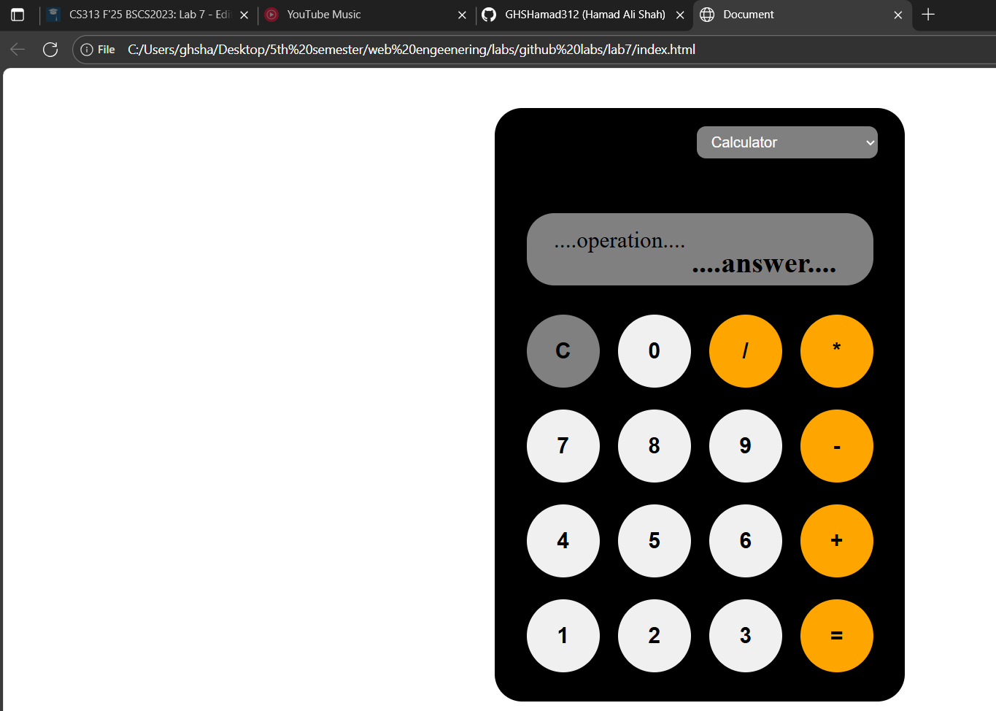
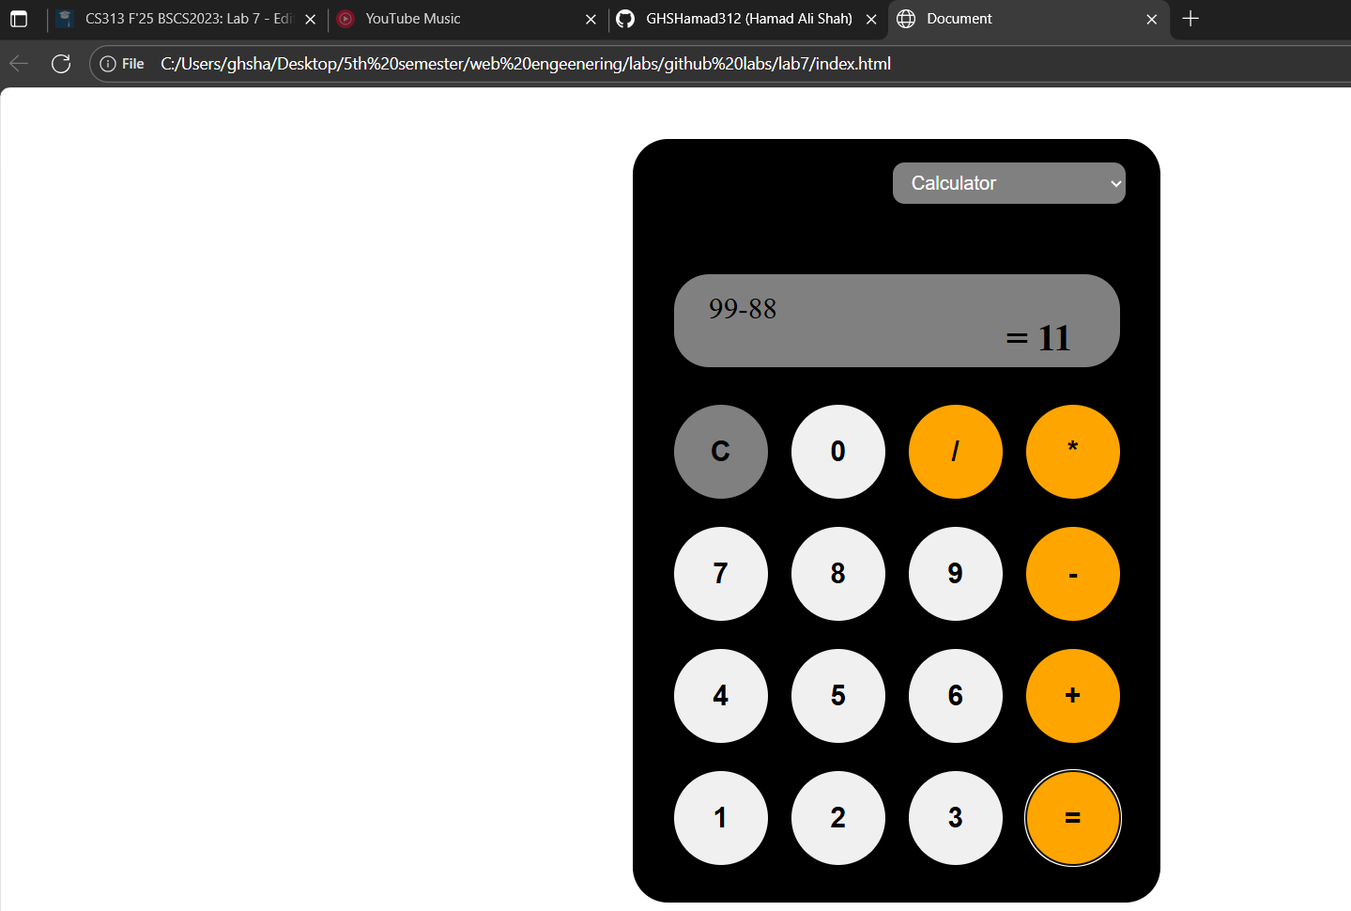
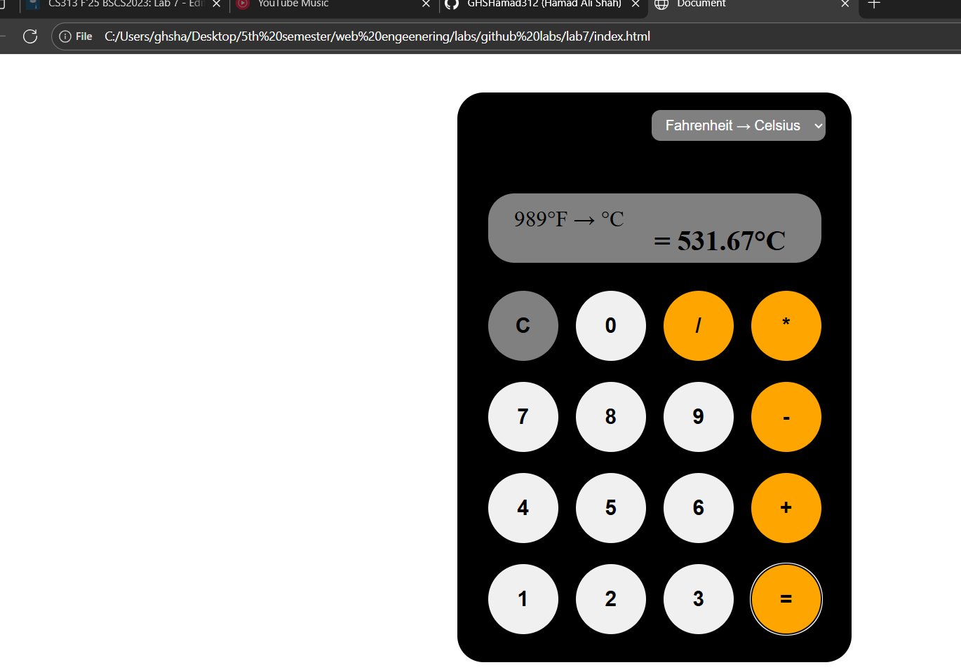

Link:
web-dev-labs/lab7 at main · GHSHamad312/web-dev-labs

